Split file – useful for datasets with multiple groups, but you want to analyze each group separately (i.e. get the mean for each group).

Data > split file

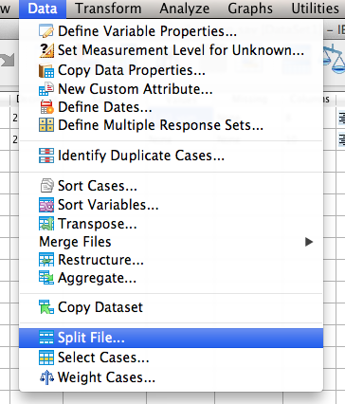

Click “organize output by groups” and move your BETWEEN SUBJECTS variable over to the groups box. If you get this wrong, you will know when you get a bunch of output you aren’t expecting. This variable should be the one with value labels usually.

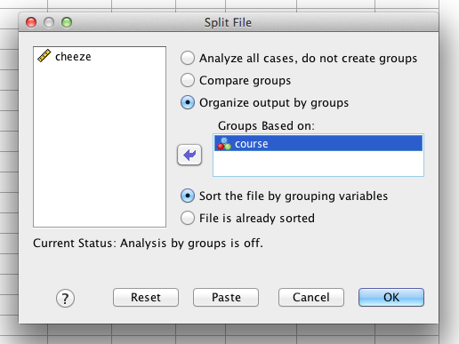

Hit ok. You will get one little line of code in the output.

To turn this split file off:

1. Close your file.
2. Data > split file.
   1. Click “analyze all cases, do not create groups”, click ok.
   2. You will want to turn it off to run comparison analyses (like ANOVA), but if you forget the type of error you’ll get it that there are no cases for group X or something similar.

Standard error – remember this is the estimation of the population standard deviation, and your sample standard deviation / square root (*n*). Remember that you want to calculate standard error separately for each group/time point usually, so we are going to use little n to denote different group sample sizes (whereas big N = total across groups, times).

Use descriptives > frequencies again.

Analyze > descriptives > frequencies

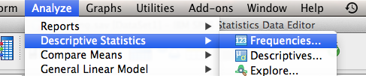

Move over the variable (that you didn’t split!).

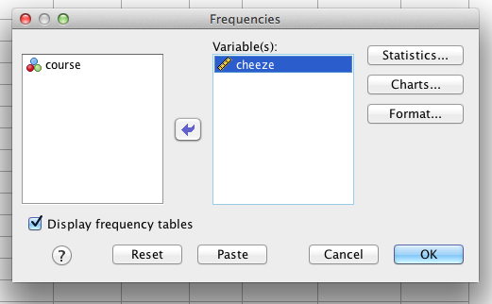

Click “statistics”. Check mean, standard deviation, and standard error (S.E. mean).

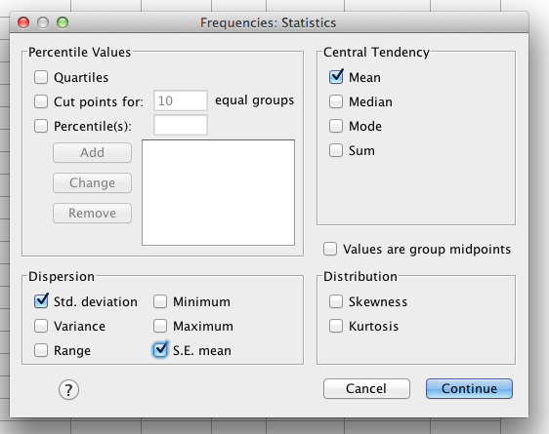

I’ve got two sets of output because I split file:

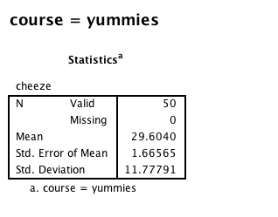

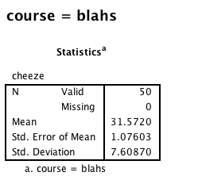

Std. Error of Mean = Standard Error = SE.

Confidence Intervals

By hand for Z-distributions:

95%

Lower = Mean – 1.96 (SE)

Upper = Mean + 1.96 (SE)

99%

Lower = Mean – 2.58 (SE)

Lower = Mean + 2.58 (SE)

For t-distributions, F-distributions

You can get these values as part of the statistic you are using automatically.

Lower = Mean – talpha (SE)

Upper = Mean + talpha (SE)

T or F alpha depend on *df*, alpha (.05, .01), number of tails for t values (tables).

Effect size Cohen’s *d* for *Z* – tests (since we are using *Z* confidence intervals).

*d*  = (M – M) / SD

G\*Power

This program is pretty awesome. We will talk about power for specific tests as we go through them – here we’ll do a short preview with this specific example:

*t*-tests (two independent groups)

Test family: t-tests

Statistical test: Means difference between 2 independent populations

Type of power analysis: compute required sample size

Input parameters:

* tails – usually we use two
* effect size d – enter the Cohen’s d for the two means
* a err prob – this is alpha, generally we use .05
* power (1-beta) – most people use .80
* Allocation ratio = N2 / N1 = sample size group 2 / sample size group 1

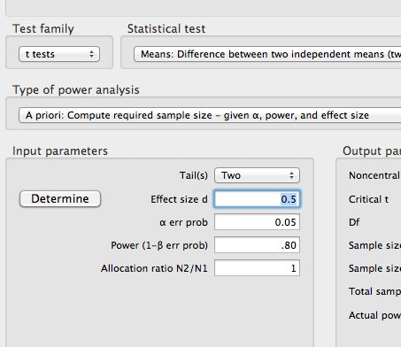

Hit calculate.

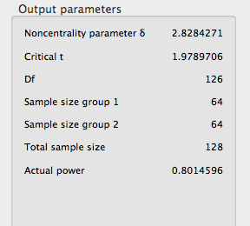

Total sample size gives you the number of N, while each n is separated into sample 1, sample 2.